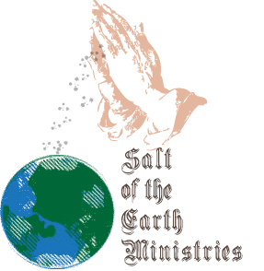

Salt of the Earth International Ministries
SHORT-TERM MISSIONS
Immunization Agreement

In the interest of providing adequate information to all volunteers, Salt of the Earth International Ministries has provided each individual with a list of immunizations. These immunizations are prescribed by the Center for Disease Control and are viewed by Salt of the Earth International Ministries as a prerequisite for departure.

I have reviewed these immunizations, have consulted with my physician concerning the necessary precautions, have complied with the recommendations of my physician, and agree to assume all risks.

____________________________
Volunteer’s Name (Print)

____________________________
Signature

____________________________
Date

